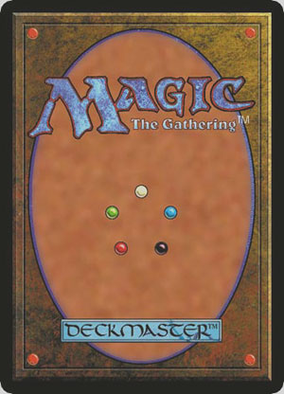
Magic

Final Due 10/22 before class

The goal of this assignment is to gain an understanding of the collectible card game (CCG) genre, and the game design principles used to create Magic: the Gathering.

As a prerequisite for this assignment, learn the basic rules of Magic. We will do an in-class demo that should help you learn. In addition, if you have access to a PC, you can play a demo version of Magic: the Gathering via this link:

http://www.wizards.com/magic/tcg/newtomagic.aspx?x=mtg/tcg/newtomagic/learntoplay

If you don’t have a PC (or even if you do), a good way to learn is to play with physical cards with anyone else. You do not need to be an expert; just ensure you have a basic understanding of the rules.

If you’re curious, here are the official tournament rules of Magic:
http://archive.wizards.com/Magic/tcg/article.aspx?x=magic/rules

Final
After reading the articles below, send an e-mail to Ira with your thoughts and analysis of Magic. Consider questions such as:
- Why is this game fun for many people?
- What do the game designers consider when creating the game?
- How does the game change over time, and why?
- What could be changed about the game to make it more fun?
- What are some possible innovations on Magic, or CCGs in general?

The articles below are written by Mark Rosewater, the lead game designer of Magic:
http://magic.wizards.com/en/articles/archive/khan-do-attitude-part-1-2014-09-01
http://magic.wizards.com/en/articles/archive/mm/khan-do-attitude-part-2-2014-09-08
http://magic.wizards.com/en/articles/archive/mm/pros-and-khans-part-1-2014-09-15

Mark writes many articles, and they’re pretty good. Below is more optional reading, in case you’re interested:
http://www.wizards.com/Magic/Magazine/Archive.aspx?author=Mark%20Rosewater

The articles below are written by Sam Stoddard, another game designer:
http://magic.wizards.com/en/articles/archive/ld/developing-khans-tarkir-2014-09-12
http://magic.wizards.com/en/articles/archive/ld/m-files-khans-tarkir-part-1-2014-09-19
http://magic.wizards.com/en/articles/archive/ld/m-files-khans-tarkir-part-2-2014-09-26

Original assignment designed by Professor Ira Fay.

